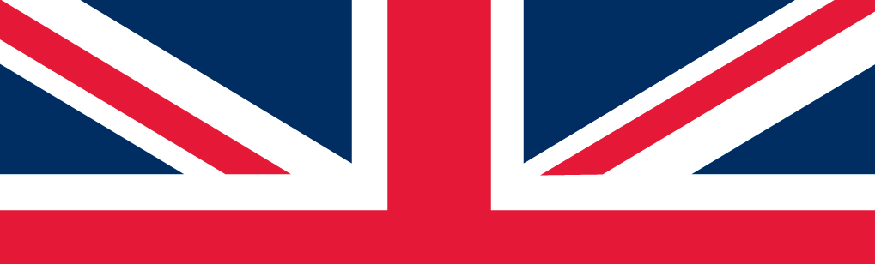
CBCF Welcome & Packet Pick-up
Sponsored by the
Illinois Flat Land British Car Club (IFLBCC)
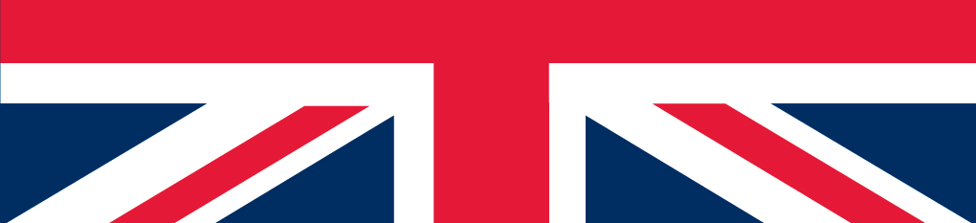
Kick off your Champagne British Car Festival weekend
Join us for the CBCF Welcome Reception
- Snacks / hors d’oeuvres served throughout the evening
- Cash bar with a variety of beverage options
- Decorated “Galleria” area of the Chateau Conference Center
- Pick up your pre-registration Welcome Packets (5-8 pm)
- Reserved parking in Conference Center lot
- Click for map, location, and more information.

Don’t miss this wonderful opportunity to meet fellow British car enthusiasts, hang out and check out each other’s cars!

Friday, June 2, 2023
5 to 9 PM

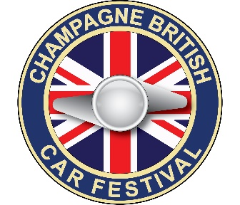
http://www.CBCF-Bloomington.com
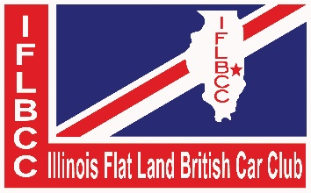
Chateau Hotel & Conference Center
1621 Jumer Dr., Bloomington, IL

